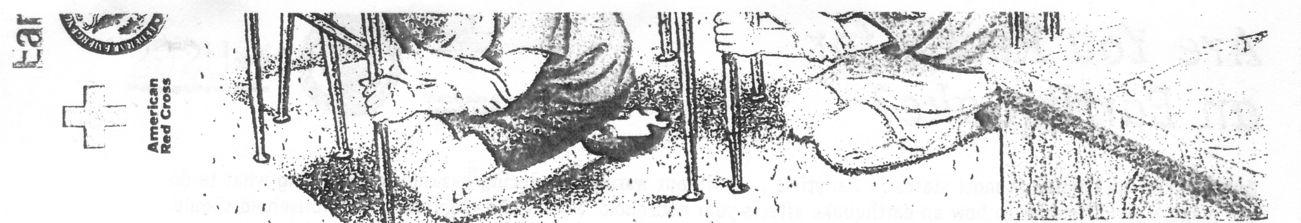

Are you ready for an earthquake?
Here's what, you can do to prepare for such an emergency

Prepare a Home Earthquake Plan
- Choose a safe place in every
room-under a sturdy table or
desk or against an inside wall
where nothing can fall on you
- Practice DROP, COVER, AND HOLD ON at least twice a year. Drop under a sturdy desk or table, hold on, and protect your eyes by pressing your face against your arm. If there's
no table or desk nearby, sit on the floor against an interior wall away from windows, bookcases, or tall furniture that could fall on you. Teach children to DROP, COVER, AND HOLD ON!
- Choose an out-of-town family
contact.
- Consult a professional to find out additional ways you can protect your home, such as bolting the house to its foundation and other
structural mitigation techniques.
- Take a first aid class from your
local Red Cross chapter. Keep
your training current.
- Get training in how to use a
fire extinguisher from your local
fire department.
- Inform babysitters and caregivers of your plan.

Eliminate hazards, by-
- Bolting bookcases, china
cabinets, and other tall
furniture to wall studs.
- Installing strong latches on
cupboards.
- Strapping the water heater
to wall studs.

Prepare a Disaster Supplies Kit
for home and car, including-
- First aid kit and essential
medications.
- Canned food and can opener.
- At least three gallons of water
per person.
- Protective clothing, rainwear,
and bedding or sleeping bags.
- Battery-powered radio, flashlight, and extra batteries.
- Special items for infant, elderly,
or disabled family members.
- Written instructions for how
to turn off gas, electricity, and
water if authorities advise you
to do so. (Remember, you'll need a professional to turn natural gas service back on.)
- Keeping essentials, such as a
flashlight and sturdy shoes,
by your bedside.

Know what to do when the shaking begins
- DROP, COVER, AND HOLD ON!
Move only a few steps to a nearby safe place. Stay indoors until the shaking stops and you're sure it's safe to exit. Stay away from windows. In a high-rise building, expect the fire alarms and sprinklers
to go off during a quake.
- If you are in bed, hold on and
stay there, protecting your head
with a pillow.

- If you are outdoors, find a clear
spot away from buildings, trees,
and power lines. Drop to the ground.
- If you are in a car, slow down and drive to a clear place (as described above). Stay in the car until the shaking stops.

Identify what to do after the
shaking stops
- Check yourself for injuries. Protect yourself from further danger by putting on long pants, a long sleeved shirt, sturdy shoes, and work gloves.
- Check others for injuries. Give
first aid for serious injuries.
- Look for and extinguish small fires. Eliminate fire hazards. Turn off the gas if you smell gas or think It's leaking. (Remember, only a professional should turn it back on.)
- Listen to the radio for instructions.
- Expect aftershocks. Each time
you feel one, DROP, COVER, AND HOLD ON!
- Inspect your home for damage.
Get everyone out if your home
is unsafe.
- Use the telephone only to report
life-threatening emergencies.

PAGE 1

Are You Ready for an Earthquake ?

Earthquakes can happen in most states ... anytime ... without warning. Reducing hazards and knowing what to do can make a big difference in how an earthquake affects your household. Adults and children in the household should talk about what you will do when an earthquake happens. This checklist will get you started in planning. Have various members of the household complete each of the items on the checklist below. Then get together to finalize your Home Earthquake Plan.

- Pick one or more "safe places" in each room of your home. Practice “DROP, COVER, AND HOLD ON” in each place.
Write the locations of safe places in each room of your home
Bedroom: ___________________________________________________________________

Bedroom: ___________________________________________________________________

Living room: _________________________________________________________________

Kitchen: ____________________________________________________________________

Other rooms: ________________________________________________________________

- Choose an out-of-town relative or friend to be a family contact person.

Family contact: _______________________________________________________________

Phone number: _______________________________________________________________

- Put together disaster supplies kits.

Location of home kit: ____________________________________________________________

Date assembled: _______________________________________________________________

Shoes and flashlight put next to everyone's bed: _______________________________________

Smaller kit put in car: _____________________________________________________________

- Teach household members how to turn off utilities.

Location of gas and water valves and electrical switches and turnoff tools: ___________________
______________________________________________________________________________

- Install strong latches or bolts on cabinets.

- Secure water heater to wall studs with two steel straps,

- Bolt bookcases, china cabinet, and tall furniture to wall studs.

- Secure items that might fall (TV, books, computers, etc.).

PAGE 2

